Table of Contents

**Problem Description** 1

**Necessity of the Project** 2

**Summary** 9

Project Specifications 10

Strategies for Maximizing Sustainability 13

Conclusion 15

Business Model Canvas 25

Visual Representation 27

**Problem Description**

1. **High Youth Unemployment:**
   * **Statistic:** Ghana's youth unemployment rate remains significantly high, with many young people between the ages of 25 and 35 struggling to find sustainable employment.
   * **Impact:** This unemployment crisis leads to economic instability and limits the potential of the young workforce to contribute positively to the economy.
2. **Lack of Vocational Training:**
   * **Training Gaps:** There is a noticeable gap in vocational training opportunities, particularly in the fashion and tailoring industry. Existing programs are either limited in scope or inaccessible to many.
   * **Skill Deficiency:** Without proper training, aspiring fashion designers and tailors cannot develop the skills necessary to succeed in the industry, leaving them uncompetitive in the job market.
3. **Inaccessibility of Resources:**
   * **Financial Constraints:** Many young individuals interested in fashion design lack the financial resources to purchase essential equipment or rent workspace, hindering their ability to start their businesses.
   * **Equipment and Facilities:** Access to professional-grade equipment and adequate workspace is often limited, which affects the quality of their work and their ability to scale their operations.
4. **Underutilization of Traditional Fabrics:**
   * **Cultural Neglect:** Traditional Ghanaian fabrics such as Kente, Fugu, and Ntoma are not fully integrated into contemporary fashion markets. This underutilization neglects a valuable cultural and economic asset.
   * **Market Potential:** There is untapped potential in promoting these fabrics within both local and international markets, which could drive economic growth and cultural preservation.
5. **Lack of Market Access:**
   * **Exposure Issues:** Many young designers and tailors struggle to market their products effectively, lacking the networks and platforms to reach potential customers.
   * **Competitive Disadvantage:** Without proper marketing channels, their businesses remain small and unable to compete with established brands.

**Necessity of the Project**

1. **Economic Empowerment:**
   * **Job Creation:** By providing comprehensive vocational training and resources, the project will equip young individuals with the skills needed to secure employment or start their own businesses, directly addressing the high unemployment rate.
   * **Economic Growth:** Empowered youth will contribute to the economy by creating new businesses, which in turn will generate additional employment opportunities.



<https://medium.com/human-resources-management/why-should-you-love-vocational-education-2cb763d133db>

1. **Skill Development:**
   * **Professional Training:** The project will offer specialized training programs that cover both basic and advanced skills in fashion design and tailoring, ensuring participants are well-prepared to enter the industry.
   * **Continuous Learning:** Ongoing mentorship and professional development programs will help participants stay updated with industry trends and continuously improve their skills.
2. **Resource Provision:**
   * **Access to Equipment:** The project will provide access to necessary tools and equipment, enabling participants to produce high-quality work and scale their operations.
   * **Shared Workspace:** By offering a communal workspace, the project will reduce the financial burden on individuals and foster a collaborative environment.

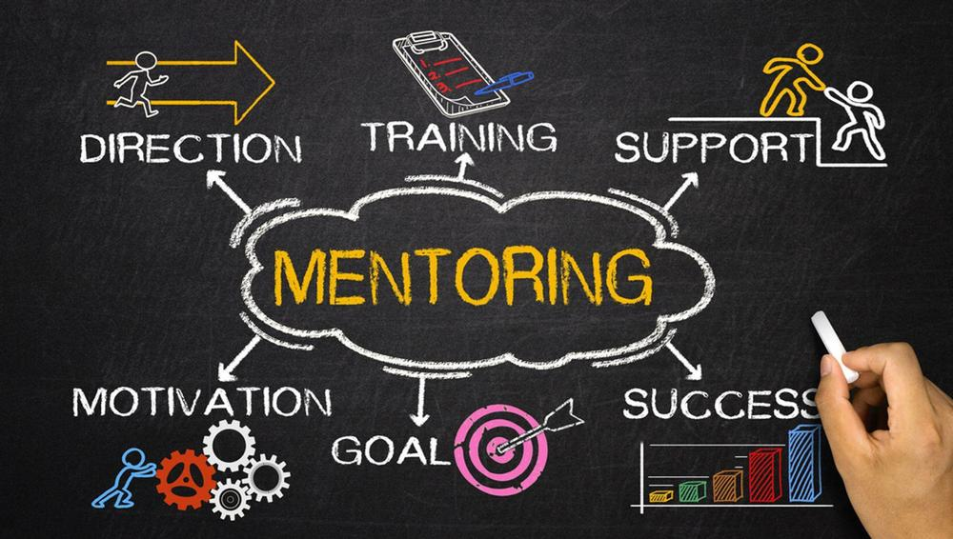

<https://cacj.georgia.gov/resources/cacj-mentor-program>

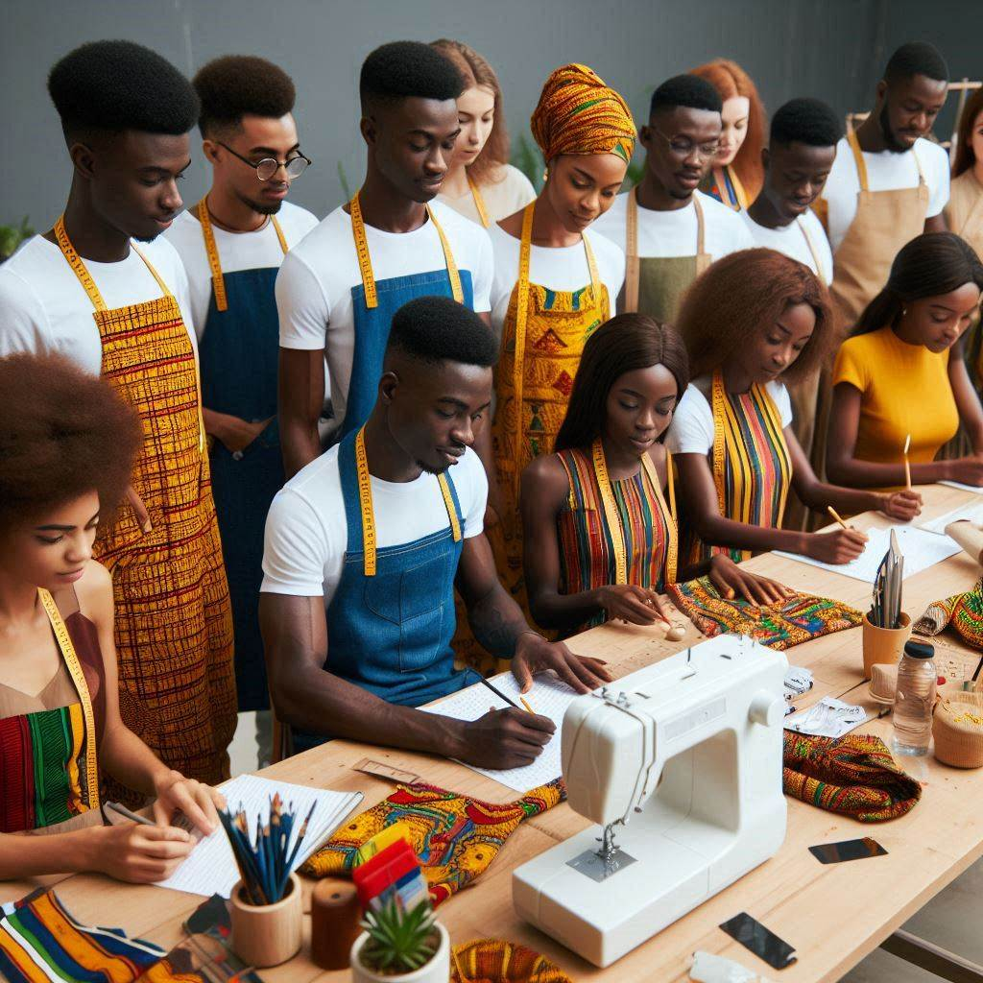

[Image Creator (bing.com)](https://www.bing.com/images/create/ghanians-undergoing-training-for-fashion-designers/1-6677d94a7b62405ea41edb853e4cf27a?id=c32YSCXQmjjKBd%2boHjtr8A%3d%3d&view=detailv2&idpp=genimg&idpclose=1&thId=OIG1.IbY6eeFGkwG1fDYf_YoC&FORM=SYDBIC)

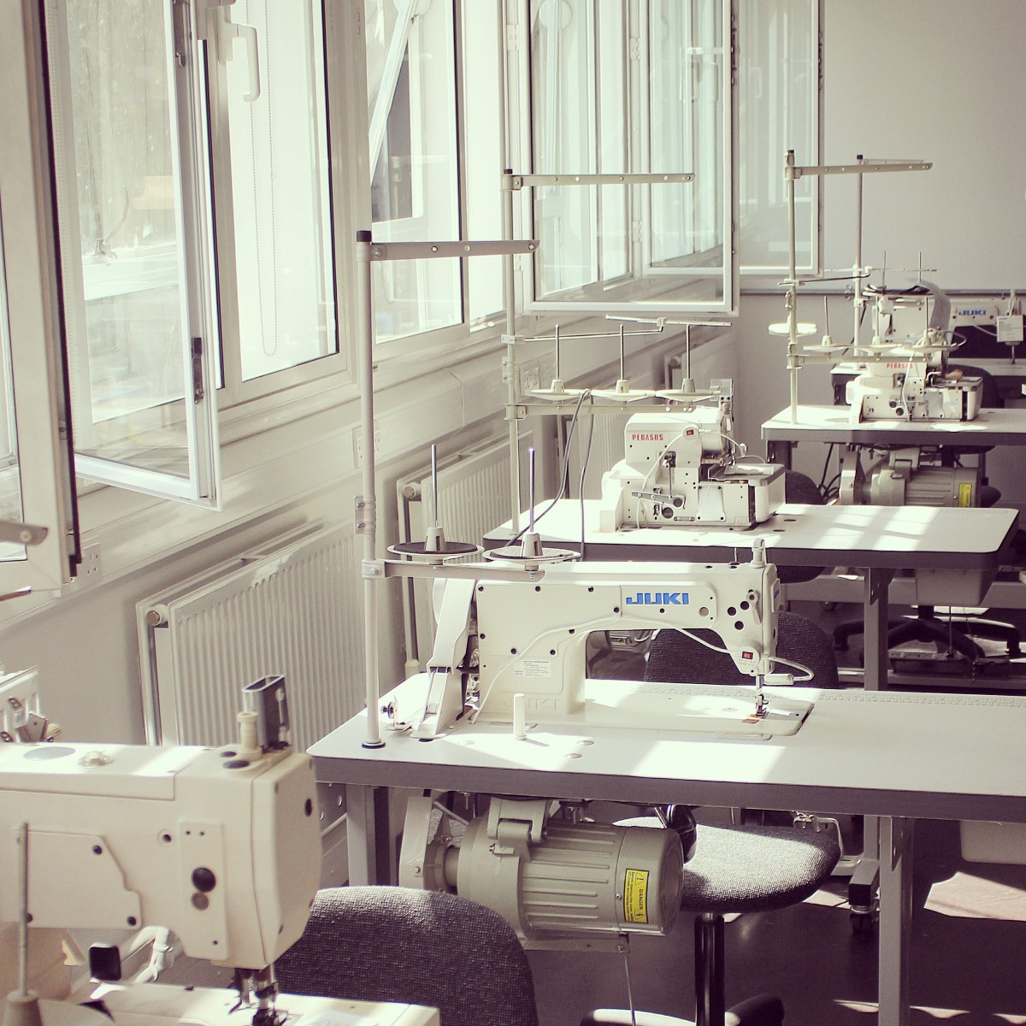

<http://news.hackney.gov.uk/the-fashion-lab---young-designers-given-access-to-high-tech-fashion-equipment/>

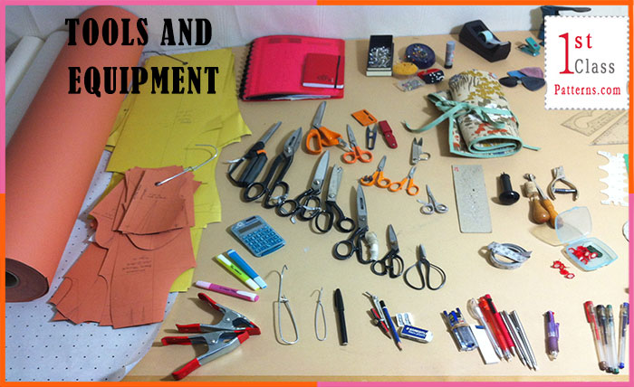

<https://1stclasspatterns.com/2016/03/13-fashion-design-tools-i-cant-live-without/>

1. **Cultural Preservation and Promotion:**
   * **Highlighting Tradition:** The project will focus on the use of traditional fabrics, promoting their significance and integrating them into modern fashion designs.
   * **Market Expansion:** Through exhibitions and fashion shows, the project will create new market opportunities for traditional fabrics, enhancing their visibility and demand.

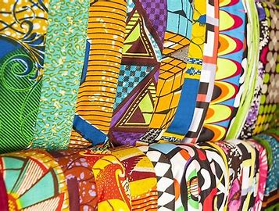

<https://www.worldatlas.com/articles/ethnic-groups-and-tribes-in-ghana.html>

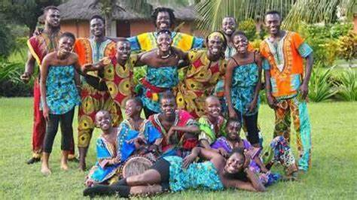

<https://prideofghanatours.securedirectbookings.com/ghana-cultural-immersion-tour-pPF0SDS.html>

1. **Market Access and Networking:**
   * **Marketing Support:** The project will assist participants in marketing their products through various channels, including online platforms and local fashion events.
   * **Exposure Opportunities:** Regular exhibitions and fashion shows will provide participants with the exposure needed to attract customers and build their brand.



<http://allstarsdigital.in/digital-marketing/the-role-of-graphic-design-in-the-digital-marketing-world/>

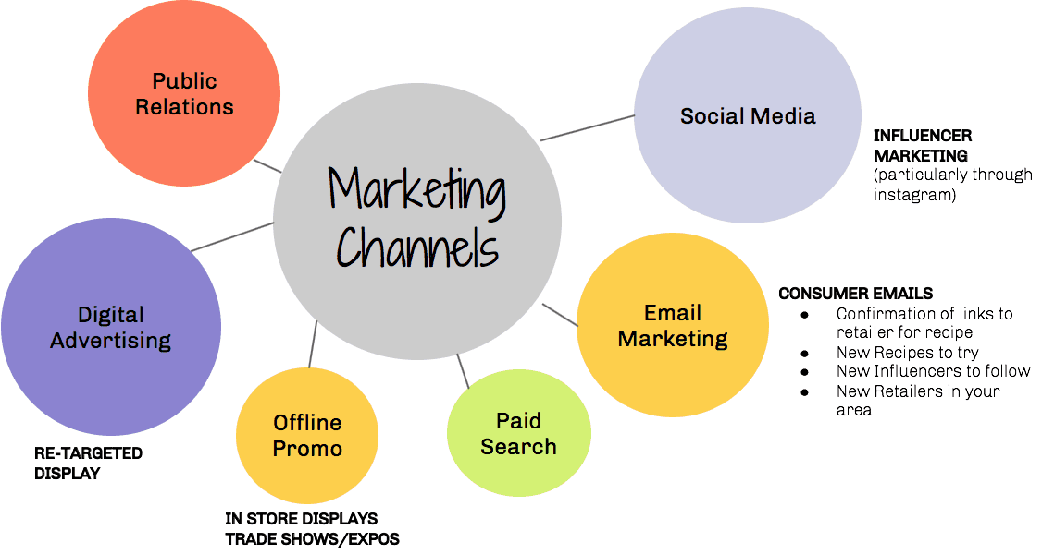

<http://webapi.bu.edu/features-of-effective-distribution-channel-design.php>

**Summary**

The project addresses critical challenges faced by young aspiring fashion designers and tailors in Ghana, including high unemployment, lack of vocational training, inaccessibility of resources, underutilization of traditional fabrics, and limited market access. By offering comprehensive training, resource provision, and market opportunities, the project aims to empower youth, preserve cultural heritage, and stimulate economic growth. This multi-faceted approach will not only reduce unemployment but also foster a vibrant and sustainable fashion industry in Ghana.

### Project Specifications

#### Objectives

1. **Empower Youth with Vocational Skills:**
   * Provide comprehensive training in fashion design and tailoring to youth aged 25-35 in Ghana.
   * Equip participants with both basic and advanced skills necessary for success in the fashion industry.
2. **Promote Traditional Ghanaian Fabrics:**
   * Integrate the use of traditional fabrics such as Kente, Fugu, and Ntoma into the training curriculum.
   * Encourage the creation of modern fashion pieces that highlight these traditional textiles.
3. **Provide Resources and Facilities:**
   * Establish training centers equipped with professional-grade tools and machines.
   * Offer shared workspace to reduce overhead costs for participants.
4. **Facilitate Market Access:**
   * Organize exhibitions and fashion shows to showcase participants' work.
   * Develop marketing strategies and partnerships to help participants reach a wider audience.
5. **Foster Continuous Professional Development:**
   * Implement mentorship programs with established fashion designers and industry experts.
   * Offer ongoing training and workshops to keep participants updated with the latest trends and techniques.

#### Target Beneficiaries

* **Primary Beneficiaries:**
  + Unemployed youth aged 25-35 in Accra, Ghana, who are interested in or currently engaged in fashion design and tailoring.
* **Secondary Beneficiaries:**
  + Local fashion industry stakeholders, including fabric suppliers and retailers, who will benefit from increased demand for traditional fabrics and new designs.
  + Broader community through economic growth and cultural preservation.

#### Key Components

1. **Training Program:**
   * **Basic Training:** Introduction to fashion design principles, sewing techniques, and fabric handling.
   * **Advanced Training:** Specialized courses in pattern making, tailoring, and fashion entrepreneurship.
   * **Workshops:** Regular workshops focusing on contemporary trends and new technologies in fashion design.
2. **Resource Provision:**
   * **Equipment:** Sewing machines, cutting tables, irons, and other essential tools.
   * **Materials:** Access to high-quality fabrics, threads, and accessories.
3. **Facilities:**
   * **Training Centers:** Located in strategic areas of Accra, equipped with all necessary facilities for comprehensive training.
   * **Shared Workspace:** Open workspace where participants can work on their projects collaboratively.
4. **Market Access Initiatives:**
   * **Exhibitions:** Regular events to display participants' creations to the public.
   * **Fashion Shows:** Seasonal fashion shows to showcase collections and attract buyers and investors.
   * **Marketing Support:** Assistance with branding, online marketing, and connecting with local and international markets.
5. **Mentorship and Development:**
   * **Mentorship Programs:** Regular sessions with experienced fashion designers and business experts.
   * **Professional Development:** Opportunities for continuous learning through advanced courses and certifications.

#### Expected Outcomes

1. **Reduction in Youth Unemployment:**
   * Increased employment and self-employment rates among participants.
2. **Economic Growth:**
   * Contribution to local economy through new businesses and increased demand for local fabrics and products.
3. **Cultural Preservation:**
   * Enhanced visibility and use of traditional Ghanaian fabrics in contemporary fashion.
4. **Enhanced Skills and Competitiveness:**
   * Participants equipped with high-level skills making them competitive in the local and international fashion markets.
5. **Community Building:**
   * Creation of a supportive network of young designers and tailors who collaborate and grow together.

Maximizing sustainability is crucial for ensuring the long-term impact and viability of the social enterprise project focused on vocational training in fashion design in Ghana. Here are several strategies to enhance sustainability:

### Strategies for Maximizing Sustainability

#### 1. **Economic Sustainability**

**Revenue Diversification:**

* **Training Fees:** Implement a sliding scale fee structure to ensure affordability while generating income.
* **Product Sales:** Sell products created by trainees, such as garments and accessories, at exhibitions, fashion shows, and online platforms.
* **Grants and Sponsorships:** Continuously seek grants and sponsorships from government agencies, NGOs, and private sector companies.
* **Consulting Services:** Offer design and tailoring services to local fashion brands and individual clients.

**Cost Management:**

* **Efficient Use of Resources:** Optimize the use of materials and equipment to minimize waste and reduce costs.
* **Shared Facilities:** Utilize shared workspace and equipment to lower operational expenses.
* **Renewable Energy Sources:** Incorporate renewable energy solutions such as solar panels to reduce utility costs and environmental impact.

#### 2. **Environmental Sustainability**

**Eco-Friendly Practices:**

* **Sustainable Fabrics:** Prioritize the use of eco-friendly and ethically sourced materials, including organic cotton and recycled fabrics.
* **Waste Reduction:** Implement waste management practices such as fabric recycling and upcycling scraps into new products.
* **Energy Efficiency:** Use energy-efficient machines and lighting systems to reduce the carbon footprint of the training centers.

**Sustainable Fashion Education:**

* **Curriculum Integration:** Include modules on sustainable fashion practices, teaching trainees about the importance of environmental responsibility in the industry.
* **Green Innovations:** Encourage the development of innovative designs that incorporate sustainable materials and methods.

#### 3. **Social Sustainability**

**Community Engagement:**

* **Local Partnerships:** Collaborate with local artisans, designers, and businesses to create a supportive ecosystem.
* **Cultural Preservation:** Emphasize the use of traditional Ghanaian fabrics and designs, fostering a sense of cultural pride and continuity.

**Inclusive Approach:**

* **Diverse Participation:** Ensure the program is accessible to a diverse group of young people, including women, people with disabilities, and those from underrepresented communities.
* **Mentorship and Support:** Provide ongoing mentorship and support to help trainees transition from training to employment or entrepreneurship.

**Capacity Building:**

* **Skill Development:** Offer continuous learning opportunities and advanced training modules to keep skills updated and relevant.
* **Leadership Training:** Develop leadership and business skills among trainees to prepare them for managerial roles and entrepreneurship.

#### 4. **Operational Sustainability**

**Strong Governance:**

* **Effective Management:** Establish a robust governance structure with clear roles and responsibilities.
* **Regular Evaluation:** Implement a monitoring and evaluation system to track progress, measure impact, and make data-driven decisions.
* **Transparency:** Maintain transparency in financial management and operations to build trust among stakeholders.

**Scalability:**

* **Pilot Program Success:** Focus on ensuring the success of the initial pilot program in Accra before scaling to other regions.
* **Replication Model:** Develop a replication model that can be adapted to different regions, taking into account local needs and contexts.

**Technology Integration:**

* **Digital Tools:** Utilize digital tools and platforms for training, marketing, and administration to enhance efficiency.
* **Online Learning:** Incorporate online learning modules to reach a broader audience and provide flexible learning options.

#### 5. **Policy Advocacy**

**Government Collaboration:**

* **Policy Support:** Work with government agencies to advocate for policies that support vocational training and sustainable fashion initiatives.
* **Funding Opportunities:** Explore government funding opportunities and incentives for sustainable projects.

**Industry Standards:**

* **Certification Programs:** Develop certification programs in collaboration with industry bodies to standardize training and ensure high-quality outcomes.
* **Sustainable Practices:** Advocate for industry-wide adoption of sustainable practices in fashion design and production.

### Conclusion

By implementing these strategies, the social enterprise can maximize its sustainability, ensuring long-term impact and success. Economic sustainability through revenue diversification and cost management, environmental sustainability through eco-friendly practices, social sustainability through community engagement and inclusivity, operational sustainability through strong governance and scalability, and policy advocacy will collectively contribute to the project's enduring viability. These efforts will empower young Ghanaians, promote cultural heritage, and foster a sustainable fashion industry in Ghana.

# **Life Cycle Use Case**

**1. Awareness**

**Objective:**

* To inform potential participants about the project and its benefits.

**Activities:**

* **Marketing Campaigns:** Online and offline campaigns to raise awareness about the training opportunities.
* **Community Engagement:** Partnering with local organizations and holding informational sessions in communities.
* **Social Media Outreach:** Using social media platforms to reach the target demographic and share success stories.

**Outcome:**

* Potential participants become aware of the program and express interest.

**2. Enrollment**

**Objective:**

* To select and enroll participants who are eager to learn fashion design and tailoring.

**Activities:**

* **Application Process:** Interested individuals submit applications detailing their background and interest.
* **Screening:** Applications are reviewed, and candidates are shortlisted based on criteria such as interest, potential, and need.
* **Interviews:** Conduct interviews to further assess candidates' motivation and suitability.
* **Selection:** Final selection of participants who will benefit the most from the program.

**Outcome:**

* A cohort of motivated participants is selected to join the program.

**3. Training**

**Objective:**

* To provide participants with foundational and advanced skills in fashion design and tailoring.

**Activities:**

* **Orientation:** Introduction to the program, facilities, trainers, and curriculum.
* **Basic Training:** Courses covering the fundamentals of fashion design, sewing, and fabric handling.
* **Advanced Training:** Specialized modules in pattern making, tailoring, and fashion entrepreneurship.
* **Workshops:** Regular workshops on the latest trends, techniques, and technologies in fashion.

**Outcome:**

* Participants acquire the necessary skills and knowledge to start working on their fashion projects.

**4. Development**

**Objective:**

* To support participants in applying their skills to real-world projects and enhance their professional development.

**Activities:**

* **Mentorship:** Pairing participants with experienced fashion designers for guidance and support.
* **Project Work:** Participants work on individual or group projects to create fashion items using traditional fabrics.
* **Continuous Learning:** Additional training sessions and seminars to keep participants updated on industry trends.
* **Feedback Sessions:** Regular feedback from trainers and mentors to help participants improve their work.

**Outcome:**

* Participants gain practical experience and develop their own fashion pieces.

**5. Market Exposure**

**Objective:**

* To provide participants with opportunities to showcase their work and connect with potential customers and industry professionals.

**Activities:**

* **Exhibitions:** Organize exhibitions to display participants' creations to the public and industry stakeholders.
* **Fashion Shows:** Host fashion shows where participants can showcase their collections on the runway.
* **Marketing Support:** Assist participants in creating marketing materials and promoting their work online and offline.
* **Networking Events:** Facilitate events where participants can meet potential buyers, collaborators, and mentors.

**Outcome:**

* Participants' work gains visibility, leading to sales, collaborations, and potential career opportunities.

**6. Post-Graduation**

**Objective:**

* To ensure participants continue to succeed after completing the program.

**Activities:**

* **Business Support:** Provide guidance on setting up and running a fashion business, including financial management and operations.
* **Alumni Network:** Create a network of program graduates for ongoing support, collaboration, and mentorship.
* **Job Placement Assistance:** Help participants find employment opportunities in the fashion industry.
* **Follow-Up:** Regular check-ins to track participants' progress and provide additional support as needed.

**Outcome:**

* Graduates continue to thrive in their careers, contributing to the local fashion industry and economy.

**Visual Representation (Flowchart)**

Here is a simplified flowchart to visualize the life cycle use case:

rust

Copy code

Awareness --> Enrollment --> Training --> Development --> Market Exposure --> Post-Graduation

1. **Awareness:** Participants become aware of the program.
2. **Enrollment:** Participants apply, are screened, and selected.
3. **Training:** Participants receive foundational and advanced training.
4. **Development:** Participants develop their skills through practical projects and mentorship.
5. **Market Exposure:** Participants showcase their work through exhibitions and fashion shows.
6. **Post-Graduation:** Participants receive ongoing support to ensure continued success.

**Detailed Example**

# **Step-by-Step Journey of a Participant**

1. **Awareness:**
   * Sarah, a 28-year-old from Accra, hears about the fashion training program through a social media post and a community informational session.
2. **Enrollment:**
   * Sarah submits an application, highlighting her passion for fashion and her struggles to find resources to start her own fashion line.
   * She is shortlisted and invited for an interview where she expresses her enthusiasm and dedication.
   * Sarah is selected to join the program based on her potential and need for support.
3. **Training:**
   * Sarah attends the orientation session and meets her trainers and fellow participants.
   * She completes the basic training, learning essential sewing techniques and design principles.
   * Sarah progresses to advanced training, mastering pattern making and tailoring skills.
4. **Development:**
   * Sarah is paired with a mentor, an established local fashion designer, who provides her with guidance and feedback.
   * She works on several projects, creating garments using Kente and Ntoma fabrics.
   * Through continuous workshops and feedback sessions, Sarah hones her skills and prepares her own fashion collection.
5. **Market Exposure:**
   * Sarah participates in an exhibition where her work is displayed to the public and industry stakeholders.
   * She showcases her collection in a fashion show, attracting attention from potential buyers and collaborators.
   * With the help of the program’s marketing support, Sarah promotes her designs online and gains a following.
6. **Post-Graduation:**
   * After completing the program, Sarah receives support in setting up her own fashion business.
   * She joins the alumni network, where she continues to receive mentorship and collaborates with other graduates.
   * Sarah secures several freelance projects and eventually hires a small team to expand her business.

Creating a Value Proposition Canvas for the social enterprise focused on empowering youth in Ghana through vocational training in fashion design and tailoring involves two key elements: the Customer Profile and the Value Map. Here's a detailed breakdown:

# **Value Proposition Canvas**

**1. Customer Profile**

**Customer Segments:**

* Unemployed youth aged 25-35 in Ghana.
* Aspiring and existing fashion designers and tailors.
* Local community and economy.

**Customer Jobs:**

* **Functional Jobs:**
  + Acquire vocational skills in fashion design and tailoring.
  + Gain employment or start a fashion business.
  + Access resources and facilities for fashion design.
* **Social Jobs:**
  + Achieve social recognition and self-esteem through fashion design.
  + Preserve and promote Ghanaian cultural heritage.
* **Emotional Jobs:**
  + Overcome the fear of unemployment.
  + Attain financial independence and security.

**Pains:**

* High unemployment rates among youth.
* Lack of access to professional training and resources.
* Financial constraints preventing business startups.
* Difficulty in marketing and reaching customers.
* Limited knowledge of advanced fashion techniques.
* Underutilization of traditional fabrics in modern designs.

**Gains:**

* Employment and self-employment opportunities.
* High-quality vocational training in fashion design and tailoring.
* Access to professional-grade equipment and facilities.
* Enhanced skills and knowledge in fashion design.
* Increased market access and customer reach.
* Cultural pride through the use of traditional fabrics.
* Financial stability and economic contribution.

**2. Value Map**

**Products and Services:**

* Comprehensive training programs (basic and advanced levels).
* Access to shared workspace equipped with necessary tools.
* Continuous mentorship and professional development.
* Marketing support and exhibition opportunities.
* Use of traditional Ghanaian fabrics in training and projects.
* Business support for setting up and managing fashion enterprises.

**Pain Relievers:**

* **Training Programs:** Provide high-quality, accessible training to overcome skill deficiencies.
* **Resource Provision:** Offer equipment and workspace to alleviate financial constraints.
* **Mentorship:** Continuous guidance to help navigate industry challenges and improve skills.
* **Market Access:** Regular exhibitions and fashion shows to increase exposure and sales.
* **Business Support:** Assistance with business setup and management to ensure sustainability.

**Gain Creators:**

* **Employment Opportunities:** Equip participants with skills to secure jobs or start businesses.
* **Cultural Integration:** Promote traditional fabrics, enhancing cultural pride and market appeal.
* **Professional Growth:** Continuous learning and development programs to stay competitive.
* **Market Expansion:** Marketing support to reach a broader audience and increase sales.
* **Economic Contribution:** Empower participants to contribute to the local economy through new businesses and employment.

**Value Proposition Canvas Summary**

**Customer Segment:** Unemployed youth aged 25-35 in Ghana aspiring to become fashion designers or tailors, local fashion industry stakeholders, and the broader community.

**Value Proposition:** The social enterprise empowers unemployed youth in Ghana by providing comprehensive vocational training in fashion design and tailoring, access to professional resources and facilities, continuous mentorship and professional development, and market access opportunities. This initiative not only addresses the high youth unemployment rate but also promotes Ghanaian cultural heritage through the use of traditional fabrics, contributing to economic growth and social empowerment.

**Visual Representation**

Here is a visual representation of the Value Proposition Canvas:

**Customer Profile**

1. **Customer Jobs**
   * Acquire vocational skills
   * Gain employment/start a business
   * Access resources and facilities
2. **Pains**
   * High unemployment
   * Lack of training resources
   * Financial constraints
   * Marketing difficulties
   * Limited advanced skills
   * Underutilization of traditional fabrics
3. **Gains**
   * Employment opportunities
   * High-quality training
   * Professional-grade equipment
   * Enhanced skills
   * Increased market access
   * Cultural pride
   * Financial stability

**Value Map**

1. **Products and Services**
   * Comprehensive training programs
   * Shared workspace
   * Mentorship
   * Marketing support
   * Use of traditional fabrics
   * Business support
2. **Pain Relievers**
   * High-quality training
   * Access to equipment and workspace
   * Continuous mentorship
   * Market access initiatives
   * Business setup assistance
3. **Gain Creators**
   * Employment/self-employment
   * Cultural integration
   * Professional growth
   * Market expansion
   * Economic contribution

By aligning the value map with the customer profile, the social enterprise can ensure it effectively meets the needs and alleviates the pains of its target customers while creating significant value and fostering economic and cultural growth

### Business Model Canvas

#### 1. Key Partners

* **Local Fabric Suppliers:** To source traditional fabrics like Kente, Fugu, and Ntoma.
* **Fashion Designers:** For mentorship and advanced training sessions.
* **Government Agencies:** For funding, support, and regulatory compliance.
* **Vocational Training Institutes:** For curriculum development and collaboration.
* **Marketing Agencies:** For promoting the enterprise and participants’ work.
* **Financial Institutions:** For providing micro-loans or financial assistance to participants.
* **Local Businesses and NGOs:** For community outreach and support.

#### 2. Key Activities

* **Training Programs:** Developing and delivering comprehensive fashion design and tailoring courses.
* **Mentorship Programs:** Connecting participants with experienced fashion designers for guidance and support.
* **Resource Provision:** Equipping training centers with professional-grade tools and materials.
* **Marketing and Promotion:** Organizing exhibitions, fashion shows, and online marketing campaigns.
* **Business Support:** Assisting participants with business setup, management, and financial planning.
* **Community Engagement:** Building awareness and fostering relationships with local communities and stakeholders.
* **Continuous Development:** Offering advanced workshops and keeping training updated with industry trends.

#### 3. Key Resources

* **Training Facilities:** Spaces equipped with necessary tools and machines for fashion design and tailoring.
* **Trainers and Mentors:** Experienced professionals providing training and mentorship.
* **Funding:** Financial resources from grants, donations, and partnerships to support operations.
* **Traditional Fabrics:** Access to high-quality local fabrics for training and production.
* **Marketing Channels:** Platforms for promoting participants' work and the enterprise.
* **Technology:** Software and tools for design, marketing, and business management.

#### 4. Value Propositions

* **Empowerment through Skills:** Providing youth with the skills needed for employment or entrepreneurship in fashion design.
* **Promotion of Culture:** Encouraging the use of traditional Ghanaian fabrics in modern fashion, preserving cultural heritage.
* **Comprehensive Support:** Offering a holistic approach with training, resources, mentorship, and market access.
* **Economic Growth:** Contributing to local economies by reducing unemployment and fostering new businesses.
* **Community Building:** Creating a network of young designers who support and inspire each other.

#### 5. Customer Relationships

* **Personalized Support:** Individual mentorship and continuous feedback to ensure personal and professional growth.
* **Community Engagement:** Regular communication through workshops, events, and social media.
* **Alumni Network:** Building a supportive community of graduates who can collaborate and mentor new participants.
* **Feedback Mechanisms:** Collecting and acting on feedback to improve programs and services.

#### 6. Channels

* **Social Media:** Using platforms like Facebook, Instagram, and Twitter for outreach and marketing.
* **Community Centers:** Hosting informational sessions and workshops in local communities.
* **Fashion Shows and Exhibitions:** Showcasing participants' work to a broader audience.
* **Partnerships:** Collaborating with local businesses, NGOs, and government agencies for outreach and support.
* **Online Platforms:** Developing a website and leveraging online marketplaces to promote and sell participants’ creations.

#### 7. Customer Segments

* **Primary:**
  + Unemployed youth aged 25-35 in Ghana interested in fashion design and tailoring.
* **Secondary:**
  + Local fashion industry stakeholders (e.g., designers, retailers).
  + Consumers interested in fashion and traditional Ghanaian fabrics.
  + Community organizations and NGOs focused on youth empowerment and cultural preservation.

#### 8. Cost Structure

* **Training Costs:** Salaries for trainers, curriculum development, and training materials.
* **Facility Costs:** Rent, utilities, and maintenance for training centers.
* **Equipment and Materials:** Costs for sewing machines, fabrics, and other essential tools.
* **Marketing and Promotion:** Expenses for marketing campaigns, exhibitions, and fashion shows.
* **Operational Costs:** Administrative expenses, technology, and logistics.
* **Mentorship Programs:** Stipends for mentors and costs for workshops and training sessions.
* **Community Engagement:** Costs associated with outreach and community events.

#### 9. Revenue Streams

* **Grants and Donations:** Funding from government programs, NGOs, and philanthropic organizations.
* **Participant Fees:** Nominal fees for training programs (with scholarships for those in need).
* **Product Sales:** Revenue from selling fashion items created by participants.
* **Exhibitions and Shows:** Ticket sales and sponsorships for fashion shows and exhibitions.
* **Consultancy Services:** Offering design and tailoring services to local businesses and individuals.
* **Partnerships:** Financial support from partnerships with local and international organizations.

### Visual Representation

A visual representation of the Business Model Canvas can be created using a template, but here is the summarized version in a table format for clarity:

| **Key Partners** | **Key Activities** | **Key Resources** | **Value Propositions** |
| --- | --- | --- | --- |
| Local Fabric Suppliers | Training Programs | Training Facilities | Empowerment through Skills |
| Fashion Designers | Mentorship Programs | Trainers and Mentors | Promotion of Culture |
| Government Agencies | Resource Provision | Funding | Comprehensive Support |
| Vocational Training Institutes | Marketing and Promotion | Traditional Fabrics | Economic Growth |
| Marketing Agencies | Business Support | Marketing Channels | Community Building |
| Financial Institutions | Community Engagement | Technology |  |
| Local Businesses and NGOs | Continuous Development |  |  |

| **Customer Relationships** | **Channels** | **Customer Segments** |
| --- | --- | --- |
| Personalized Support | Social Media | Unemployed Youth (25-35) |
| Community Engagement | Community Centers | Local Fashion Industry |
| Alumni Network | Fashion Shows and Exhibitions | Consumers Interested in Fashion |
| Feedback Mechanisms | Partnerships | Community Organizations |
|  | Online Platforms |  |

| **Cost Structure** | **Revenue Streams** |
| --- | --- |
| Training Costs | Grants and Donations |
| Facility Costs | Participant Fees |
| Equipment and Materials | Product Sales |
| Marketing and Promotion | Exhibitions and Shows |
| Operational Costs | Consultancy Services |
| Mentorship Programs | Partnerships |
| Community Engagement |  |

This Business Model Canvas comprehensively covers the critical elements of the social enterprise, ensuring a structured and strategic approach to achieving its mission of empowering youth through vocational training in fashion design and tailoring in Ghana.

**Slide Title: Maximizing Sustainability**

**Slide Script:**

**Introduction:** Welcome to the "Maximizing Sustainability" section of our presentation. In this segment, we will explore the strategies and practices we plan to implement to ensure that our project is not only successful but also sustainable in the long term. Sustainability is crucial for creating lasting impacts and for the continuous growth of our social enterprise.

**1. Economic Sustainability:** Economic sustainability is vital for the longevity of our project. We aim to achieve this through several key strategies:

* **Diversified Revenue Streams:** By generating income from multiple sources, including participant fees, product sales, exhibitions, fashion shows, and consultancy services, we reduce dependency on any single revenue source.
* **Financial Management:** Implementing sound financial practices and maintaining transparent financial records will help in managing funds efficiently, ensuring the project's financial health and stability.

**2. Environmental Sustainability:** Our commitment to environmental sustainability focuses on minimizing our ecological footprint and promoting eco-friendly practices:

* **Sustainable Materials:** Prioritizing the use of eco-friendly and sustainable materials in our fashion products, such as organic fabrics and natural dyes.
* **Waste Reduction:** Implementing waste reduction strategies, including recycling and upcycling fabric scraps, to minimize waste generated from our production processes.
* **Energy Efficiency:** Utilizing energy-efficient equipment and adopting practices that reduce energy consumption in our training centers and workshops.

**3. Social Sustainability:** Social sustainability involves creating a positive impact on our community and ensuring the well-being of our participants:

* **Community Engagement:** Actively engaging with local communities to understand their needs and to ensure our project aligns with their expectations. This includes hosting community events and workshops to foster a sense of belonging and participation.
* **Inclusivity and Diversity:** Ensuring that our project is inclusive and accessible to all, regardless of gender, socioeconomic background, or physical ability. We will promote diversity and equality in our training programs and workspaces.
* **Health and Safety:** Prioritizing the health and safety of our participants by providing safe working conditions, access to health services, and regular safety training.

**4. Cultural Sustainability:** Cultural sustainability focuses on preserving and promoting Ghanaian cultural heritage through our project:

* **Traditional Fabrics:** Emphasizing the use of traditional Ghanaian fabrics such as Kente, Fugu, and Ntoma in our fashion designs to preserve and promote local culture.
* **Cultural Awareness:** Educating our participants and the broader community about the cultural significance of these fabrics and integrating cultural elements into our training programs and fashion shows.
* **Global Promotion:** Showcasing Ghanaian cultural heritage on global platforms through international exhibitions and collaborations, thereby enhancing cultural appreciation and economic opportunities.

**Conclusion:** By integrating these sustainability strategies into our project, we aim to create a robust and enduring social enterprise that not only addresses the immediate needs of our participants but also contributes to the long-term economic, environmental, social, and cultural well-being of our community. Thank you for your attention.

**Identifying and Validating Our Market**

**Slide Script:**

**Introduction:** Welcome to the "Identifying and Validating Our Market" section of our presentation. In this part, we will discuss how we have identified our target market and the steps we have taken to validate its potential. Understanding and confirming our market is crucial for the success of our social enterprise.

**1. Identifying the Target Market:** Our primary target market consists of unemployed and underemployed youth aged 25-35 in Ghana, particularly in urban areas like Accra. This segment has been chosen due to several compelling reasons:

* **High Unemployment Rates:** This age group faces significant unemployment challenges, making them ideal beneficiaries of vocational training programs aimed at economic empowerment.
* **Demographic Advantage:** With a substantial youth population in Ghana, focusing on this age group ensures a large pool of potential participants and future entrepreneurs.

**2. Market Segmentation:** We have segmented our target market based on specific characteristics to tailor our approach effectively:

* **Demographics:** Youth aged 25-35, residing in urban areas.
* **Education Level:** Individuals with at least secondary education, with a preference for those with some exposure to fashion or vocational training.
* **Economic Status:** Low to middle-income individuals facing financial barriers to starting their own businesses.
* **Psychographics:** Individuals with aspirations of self-reliance, a strong interest in fashion design, and a desire to contribute to their community.

Beachhead market

**Secondary Consumer Segment: Local Fashion Industry Stakeholders:** Our secondary consumer segment includes various stakeholders within the local fashion industry, such as:

* **Fashion Designers:** Established designers who can provide mentorship and advanced training.
* **Retailers:** Businesses that can sell the products created by our participants.
* **Consumers:** Individuals interested in purchasing unique, high-quality fashion items, particularly those made with traditional Ghanaian fabrics.

**Tertiary Consumer Segment: Community Organizations and NGOs:** Our tertiary consumer segment includes community organizations and non-governmental organizations (NGOs) focused on youth empowerment and cultural preservation. These organizations can:

* **Partner with Us:** Collaborate on projects, provide funding, and offer additional resources.
* **Support Our Mission:** Advocate for our programs and help raise awareness within the community.

**Tailored Services for Each Segment:** We provide tailored services to meet the needs of each consumer segment:

* **For Unemployed Youth:** Comprehensive vocational training, access to equipment and workspaces, mentorship, and business support.
* **For Fashion Industry Stakeholders:** Opportunities for collaboration, showcasing products, and participating in our exhibitions and fashion shows.
* **For Community Organizations and NGOs:** Partnership opportunities, joint initiatives, and community engagement programs.

**Consumer Persona 1: Kwame - The Aspiring Fashion Designer**

**Name:** Kwame Mensah  
**Age:** 27  
**Location:** Accra, Ghana  
**Education Level:** Secondary education  
**Employment Status:** Unemployed  
**Income Level:** Low  
**Interests:** Fashion design, entrepreneurship, cultural heritage  
**Goals:**

* To gain professional skills in fashion design.
* To start his own fashion business.
* To create modern designs using traditional Ghanaian fabrics. **Challenges:**
* Lack of access to professional-grade equipment.
* Limited financial resources to start a business.
* Inadequate vocational training opportunities. **Needs:**
* Comprehensive vocational training.
* Access to shared workspaces and professional tools.
* Mentorship from experienced designers.

**Consumer Persona 2: Abena - The Experienced Tailor**

**Name:** Abena Asare  
**Age:** 30  
**Location:** Kumasi, Ghana  
**Education Level:** Vocational training  
**Employment Status:** Underemployed  
**Income Level:** Middle  
**Interests:** Tailoring, fashion design, community involvement  
**Goals:**

* To expand her small tailoring business.
* To learn advanced fashion design techniques.
* To network with other fashion professionals. **Challenges:**
* Inadequate workspace and equipment.
* Difficulty in accessing market opportunities.
* Limited exposure to industry trends. **Needs:**
* Advanced training programs.
* Marketing support and exposure opportunities.
* Financial assistance for business expansion.

**Consumer Persona 3: Kojo - The Young Entrepreneur**

**Name:** Kojo Boateng  
**Age:** 25  
**Location:** Accra, Ghana  
**Education Level:** Tertiary education in business  
**Employment Status:** Unemployed  
**Income Level:** Low  
**Interests:** Entrepreneurship, fashion innovation, technology  
**Goals:**

* To start a tech-enabled fashion business.
* To incorporate traditional fabrics into modern designs.
* To create a sustainable business model. **Challenges:**
* Lack of start-up capital.
* Limited business management skills specific to fashion.
* Difficulty in sourcing high-quality traditional fabrics. **Needs:**
* Business development support.
* Access to funding and resources.
* Networking opportunities with fabric suppliers and industry experts.

**Consumer Persona 4: Ama - The Community Advocate**

**Name:** Ama Osei  
**Age:** 32  
**Location:** Tamale, Ghana  
**Education Level:** Secondary education  
**Employment Status:** Employed at an NGO  
**Income Level:** Middle  
**Interests:** Community development, youth empowerment, cultural preservation  
**Goals:**

* To empower local youth through vocational training.
* To preserve and promote traditional Ghanaian fabrics.
* To collaborate with other organizations on cultural projects. **Challenges:**
* Limited vocational training programs in rural areas.
* Difficulty in mobilizing resources and support.
* Need for effective collaboration with local businesses and stakeholders. **Needs:**
* Partnership opportunities with vocational training institutes.
* Access to training materials and resources.
* Support for community engagement initiatives.

**Consumer Persona 5: Nana - The Established Fashion Designer**

**Name:** Nana Adom  
**Age:** 35  
**Location:** Accra, Ghana  
**Education Level:** Tertiary education in fashion design  
**Employment Status:** Self-employed  
**Income Level:** High  
**Interests:** High fashion, mentoring, cultural fashion integration  
**Goals:**

* To mentor upcoming fashion designers.
* To promote traditional fabrics in high fashion.
* To collaborate on innovative fashion projects. **Challenges:**
* Limited platforms for showcasing cultural designs.
* Need for continuous professional development.
* Finding talented and trained assistants. **Needs:**
* Opportunities to mentor and train young designers.
* Access to advanced workshops and seminars.
* Platforms for showcasing designs and networking.

These consumer personas provide a detailed overview of different target audience segments, their characteristics, goals, challenges, and needs. They help in understanding the diverse consumer base and tailoring the social enterprise’s offerings accordingly.

**Product Development Process: Empowered FashionCraft Ghana**

**1. Conceptualization**

**Objective:** Define the vision and goals of the project's product offerings.

1. **Idea Generation**
   * **Actions:** Brainstorming sessions with stakeholders to generate ideas for vocational training programs, skill development modules, and marketable products.
   * **Outputs:** Initial concepts and project scope defined.

**2. Design and Prototyping**

**Objective:** Translate concepts into tangible products and training modules.

1. **Curriculum Development**
   * **Actions:** Collaborate with fashion designers, vocational trainers, and educational experts to design comprehensive training curricula covering traditional Ghanaian fabrics (e.g., Kente, Fugu, Ntoma) and modern fashion trends.
   * **Outputs:** Detailed training modules and lesson plans.
2. **Prototype Development**
   * **Actions:** Create prototypes of vocational training workshops, facility layouts, and promotional materials (e.g., brochures, website mock-ups) to visualize the project's offerings.
   * **Outputs:** Physical and digital prototypes ready for testing and feedback.

**3. Testing and Validation**

**Objective:** Assess prototypes and gather feedback for refinement.

1. **Pilot Testing**
   * **Actions:** Implement pilot vocational training programs in selected locations in Accra, Ghana.
   * **Outputs:** Feedback from participants and trainers on program effectiveness, curriculum relevance, and logistical considerations.
2. **Feedback Analysis**
   * **Actions:** Analyze feedback from pilot tests to identify strengths, weaknesses, and areas for improvement in both training content and operational processes.
   * **Outputs:** Insights to refine and optimize program elements.

**4. Implementation and Scaling**

**Objective:** Roll out full-scale implementation across multiple locations.

1. **Scaling Strategy**
   * **Actions:** Develop a phased scaling plan based on pilot results, funding availability, and strategic partnerships.
   * **Outputs:** Detailed roadmap for expanding training centers, increasing participant enrollment, and enhancing market reach.
2. **Infrastructure Setup**
   * **Actions:** Establish vocational training centers equipped with necessary tools, materials, and technology infrastructure.
   * **Outputs:** Functional training facilities ready to accommodate a larger cohort of participants.

**5. Launch and Marketing**

**Objective:** Introduce the project to the public and attract participants and stakeholders.

1. **Marketing Campaign**
   * **Actions:** Launch a multi-channel marketing campaign utilizing social media, local media outlets, and community events to raise awareness about Empowered FashionCraft Ghana.
   * **Outputs:** Increased visibility, participant enrollment, and stakeholder engagement.
2. **Community Engagement**
   * **Actions:** Host workshops, open houses, and informational sessions to engage with local communities, potential participants, and partner organizations.
   * **Outputs:** Strong community support and partnerships established.

**6. Monitoring and Optimization**

**Objective:** Monitor project performance, gather data for continuous improvement.

1. **Performance Monitoring**
   * **Actions:** Establish key performance indicators (KPIs) related to participant satisfaction, skill development outcomes, and economic impact.
   * **Outputs:** Regular performance reports and data-driven insights.
2. **Continuous Improvement**
   * **Actions:** Implement feedback loops and continuous improvement processes to refine training programs, update curricula, and adapt to evolving market needs.
   * **Outputs:** Enhanced program effectiveness and participant success rates.

**7. Sustainability and Growth**

**Objective:** Ensure long-term sustainability and plan for future growth.

1. **Financial Sustainability**
   * **Actions:** Diversify revenue streams through product sales, grants, and partnerships.
   * **Outputs:** Financial stability and resilience against economic challenges.
2. **Expansion Strategy**
   * **Actions:** Explore opportunities for geographical expansion and diversification of training programs (e.g., advanced workshops, specialized courses).
   * **Outputs:** Extended reach and increased impact on youth empowerment and cultural preservation.

This simulated product development process outlines the systematic steps involved in bringing the offerings of "Empowered FashionCraft Ghana" from concept to implementation, emphasizing iterative testing, stakeholder engagement, and sustainable growth strategies.

**Feasibility Study: Empowered FashionCraft Ghana**

**1. Market Feasibility**

**Objective:** Assess the demand and potential market for vocational training in fashion design and tailoring among youth in Ghana.

1. **Market Analysis**
   * **Target Audience:** Youth aged 25-35 in urban areas of Ghana, particularly Accra.
   * **Market Size:** Estimate the number of potential participants interested in vocational training.
   * **Trends:** Analyze trends in fashion consumption, cultural preservation, and youth entrepreneurship.
2. **Competitive Landscape**
   * **Existing Programs:** Identify current vocational training programs in fashion design and their offerings.
   * **Unique Selling Proposition (USP):** Determine what sets "Empowered FashionCraft Ghana" apart from competitors.
   * **Barriers to Entry:** Evaluate regulatory requirements, operational challenges, and market entry barriers.
3. **Demand Validation**
   * **Surveys and Interviews:** Conduct surveys and interviews with target demographics to gauge interest, preferred program features, and willingness to pay.
   * **Pilot Program Results:** Utilize feedback from pilot vocational training sessions to validate market demand and refine program offerings.

**2. Technical Feasibility**

**Objective:** Evaluate the technical requirements and infrastructure needed to deliver vocational training programs effectively.

1. **Facilities and Equipment**
   * **Space Requirements:** Assess space needs for training workshops, classrooms, and administrative offices.
   * **Equipment:** Identify necessary tools, sewing machines, computers, and software for training participants.
   * **Technology:** Evaluate IT infrastructure for online learning platforms, digital design tools, and communication systems.
2. **Training Curriculum**
   * **Curriculum Development:** Collaborate with fashion experts and educators to design comprehensive training modules.
   * **Instructional Methods:** Determine effective teaching methods, hands-on training approaches, and assessment criteria.
   * **Quality Assurance:** Establish protocols for curriculum review, update cycles, and adherence to industry standards.

**3. Financial Feasibility**

**Objective:** Determine the financial viability and sustainability of "Empowered FashionCraft Ghana".

1. **Cost Analysis**
   * **Startup Costs:** Estimate initial investments in facilities, equipment, curriculum development, and marketing.
   * **Operational Expenses:** Forecast ongoing costs such as rent, utilities, salaries, and maintenance.
   * **Revenue Projections:** Project income from participant fees, product sales, grants, and partnerships.
2. **Funding Sources**
   * **Grants and Donations:** Identify potential sources of funding from government programs, NGOs, and philanthropic organizations.
   * **Partnerships:** Explore collaborations with local businesses, fashion brands, and vocational training institutes for financial support.
3. **Financial Sustainability**
   * **Break-Even Analysis:** Calculate the point at which revenues equal expenses to achieve financial sustainability.
   * **Profitability:** Assess potential profitability and return on investment over time.
   * **Risk Management:** Identify financial risks and develop mitigation strategies.

**4. Operational Feasibility**

**Objective:** Evaluate the operational capabilities and logistics required to deliver vocational training effectively.

1. **Human Resources**
   * **Staffing Needs:** Determine staffing requirements for trainers, administrators, mentors, and support staff.
   * **Recruitment:** Develop recruitment strategies and criteria for hiring qualified personnel.
   * **Training and Development:** Plan for ongoing professional development and mentorship for staff members.
2. **Logistics**
   * **Supply Chain:** Establish relationships with local fabric suppliers and equipment vendors.
   * **Facility Management:** Outline procedures for facility maintenance, security, and health/safety protocols.
   * **IT Infrastructure:** Ensure robust IT systems for data management, communication, and online learning platforms.

**5. Social and Environmental Feasibility**

**Objective:** Assess the project's impact on social empowerment and environmental sustainability.

1. **Social Impact**
   * **Youth Empowerment:** Measure the project's contribution to skill development, job creation, and economic empowerment.
   * **Cultural Preservation:** Evaluate efforts to promote traditional Ghanaian fabrics and cultural heritage.
   * **Community Engagement:** Assess community support and involvement in project activities.
2. **Environmental Impact**
   * **Sustainable Practices:** Consider eco-friendly initiatives in facility management, resource utilization, and product development.
   * **Waste Management:** Implement recycling and waste reduction measures where applicable.

This feasibility study provides a structured approach to evaluating the viability of "Empowered FashionCraft Ghana" across market demand, technical requirements, financial sustainability, operational capabilities, and social/environmental impact. Adjustments and refinements can be made based on findings to ensure the project's success and long-term viability.

Certainly! Here's a stakeholder analysis for "Empowered FashionCraft Ghana," identifying key stakeholders and their roles:

**Stakeholder Analysis: Empowered FashionCraft Ghana**

**1. Key Stakeholders**

**1. Youth Participants**

* **Role:** Beneficiaries of vocational training in fashion design and tailoring.
* **Interest:** Skill development, job opportunities, and entrepreneurship in the fashion industry.
* **Influence:** Direct impact on program success through participation and engagement.

**2. Fashion Designers and Mentors**

* **Role:** Experienced professionals providing guidance and mentorship.
* **Interest:** Developing talent, fostering creativity, and advancing the local fashion industry.
* **Influence:** Influential in shaping curriculum, providing industry insights, and enhancing participant skills.

**3. Vocational Training Institutes**

* **Role:** Partners in curriculum development and training delivery.
* **Interest:** Enhancing vocational education, supporting youth empowerment, and industry collaboration.
* **Influence:** Provides expertise, resources, and certification pathways for participants.

**4. Government Agencies**

* **Role:** Regulatory oversight, funding support, and policy advocacy.
* **Interest:** Addressing youth unemployment, promoting vocational training, and economic development.
* **Influence:** Provides funding opportunities, regulatory compliance guidelines, and advocacy for vocational education.

**5. Local Fabric Suppliers**

* **Role:** Providers of traditional Ghanaian fabrics like Kente, Fugu, and Ntoma.
* **Interest:** Promoting local textiles, expanding market reach, and cultural preservation.
* **Influence:** Ensures access to quality materials, supports cultural initiatives, and potentially sponsors events.

**6. Financial Institutions**

* **Role:** Potential funders through loans, grants, or financial support programs.
* **Interest:** Investing in youth entrepreneurship, economic growth, and community development.
* **Influence:** Provides financial resources critical for startup costs, operational expenses, and sustainability.

**7. Community Organizations**

* **Role:** Enhancing community engagement, outreach, and support.
* **Interest:** Youth empowerment, cultural initiatives, and local economic development.
* **Influence:** Provides networking opportunities, community support, and enhances project visibility.

**8. Fashion Industry Associations**

* **Role:** Industry representation, networking, and advocacy.
* **Interest:** Promoting professionalism, standards, and innovation in the fashion sector.
* **Influence:** Provides access to industry events, networks, and opportunities for collaboration and promotion.

**2. Mapping Stakeholder Engagement**

**High Power, High Interest:**

* Youth Participants, Fashion Designers/Mentors, Vocational Training Institutes, Government Agencies.

**High Power, Low Interest:**

* Financial Institutions (Dependent on funding decisions).

**Low Power, High Interest:**

* Local Fabric Suppliers, Community Organizations, Fashion Industry Associations.

**Low Power, Low Interest:**

* N/A (No identified stakeholders in this category).

This stakeholder analysis identifies key stakeholders for "Empowered FashionCraft Ghana," highlighting their roles, interests, and potential influence on the project's success. Effective engagement and collaboration with these stakeholders are crucial for achieving project objectives, ensuring sustainability, and maximizing impact on youth empowerment and cultural preservation in Ghana's fashion industry.

**Risk Management Plan: Empowered FashionCraft Ghana**

**1. Risk Identification**

**1. Financial Risks**

* **Description:** Insufficient funding or budget overruns could hinder operations, training quality, and resource provision.
* **Mitigation:** Diversify funding sources (grants, donations, partnerships), budget contingency planning, and financial oversight.

**2. Operational Risks**

* **Description:** Issues with logistics, supply chain disruptions, or inadequate facilities could impact program delivery.
* **Mitigation:** Establish robust operational procedures, maintain backup suppliers, and regular maintenance of facilities.

**3. Market Risks**

* **Description:** Fluctuating market demand, changes in consumer preferences, or ineffective marketing strategies may affect product sales and sustainability.
* **Mitigation:** Conduct market research, adapt marketing strategies, and foster customer relationships through feedback mechanisms.

**4. Regulatory and Compliance Risks**

* **Description:** Non-compliance with local regulations, licensing requirements, or legal challenges could halt operations.
* **Mitigation:** Stay updated on regulatory changes, adhere to legal requirements, and seek legal counsel for compliance issues.

**5. Talent Risks**

* **Description:** Difficulty in attracting and retaining skilled trainers and mentors could impact program quality and participant satisfaction.
* **Mitigation:** Develop competitive compensation packages, offer professional development opportunities, and foster a supportive work environment.

**6. Stakeholder Risks**

* **Description:** Disagreements with stakeholders, lack of stakeholder engagement, or conflicting interests may derail project progress.
* **Mitigation:** Establish clear communication channels, conduct regular stakeholder meetings, and address concerns promptly.

**2. Risk Assessment and Prioritization**

**High Risk:**

* Financial risks due to reliance on limited funding sources.
* Operational risks related to logistical challenges and facility management.
* Market risks from unpredictable consumer trends and competitive pressures.

**Medium Risk:**

* Regulatory risks involving compliance with local laws and regulations.
* Talent risks in attracting and retaining qualified trainers and mentors.

**Low Risk:**

* Stakeholder risks from minor disagreements or misunderstandings.

**3. Risk Response Strategies**

**1. Risk Avoidance:**

* Conduct thorough financial planning and budgeting.
* Proactively monitor and maintain operational facilities.

**2. Risk Reduction:**

* Diversify funding sources and maintain financial reserves.
* Develop robust supply chain and logistics strategies.

**3. Risk Transfer:**

* Purchase insurance coverage for property and liability risks.
* Seek legal advice to mitigate regulatory compliance risks.

**4. Risk Acceptance:**

* Monitor market trends and adjust marketing strategies accordingly.
* Address stakeholder concerns promptly and transparently.

**4. Monitoring and Review**

**1. Implementation Monitoring:**

* Regularly assess financial performance against budget forecasts.
* Monitor operational efficiency and logistical performance.

**2. Risk Evaluation:**

* Review market trends and consumer feedback for proactive adjustments.
* Evaluate stakeholder engagement and satisfaction levels.

**3. Continuous Improvement:**

* Update risk management strategies based on lessons learned and evolving risks.
* Conduct periodic reviews of policies, procedures, and stakeholder relationships.

**5. Contingency Planning**

**1. Contingency Funds:**

* Maintain emergency funds to address unexpected financial challenges.
* Develop alternative funding strategies in case of funding shortfalls.

**2. Crisis Communication Plan:**

* Establish protocols for handling emergencies, stakeholder crises, or public relations issues.
* Communicate transparently with stakeholders and the public during crises.

This risk management plan for "Empowered FashionCraft Ghana" outlines proactive measures to identify, assess, mitigate, and monitor risks across financial, operational, market, regulatory, talent, and stakeholder domains. By implementing these strategies, the project aims to minimize disruptions, ensure sustainability, and achieve its objectives effectively.

**Elaboration on Financial Risks and Risk Levels**

Financial risks are critical considerations for "Empowered FashionCraft Ghana," impacting its ability to sustain operations, deliver quality training, and achieve long-term objectives. Here’s an elaboration on financial risks categorized by risk levels:

**High Financial Risks**

1. **Insufficient Funding:**
   * **Risk Description:** Dependency on limited funding sources such as grants and donations may result in inadequate financial resources to support ongoing operations, training programs, and facility maintenance.
   * **Risk Level:** High
   * **Mitigation Strategies:** Diversify funding streams by seeking partnerships with corporate sponsors, exploring crowdfunding platforms, and applying for a mix of local and international grants. Establish a contingency fund to buffer against funding fluctuations and unexpected expenses.
2. **Budget Overruns:**
   * **Risk Description:** Inaccurate budgeting or unexpected cost escalations in operational expenses (e.g., rent, utilities, equipment maintenance) could strain financial resources and impact program quality and participant satisfaction.
   * **Risk Level:** High
   * **Mitigation Strategies:** Implement rigorous financial oversight and monitoring mechanisms to track expenses against budget allocations. Conduct regular financial reviews and adjustments to ensure alignment with revenue projections and operational needs. Maintain a reserve fund for emergencies and unforeseen expenses.

**Medium Financial Risks**

1. **Cash Flow Management:**
   * **Risk Description:** Challenges in managing cash flow effectively may lead to liquidity issues, affecting the timely payment of salaries, procurement of materials, and fulfillment of financial obligations.
   * **Risk Level:** Medium
   * **Mitigation Strategies:** Develop cash flow forecasts and projections to anticipate periods of financial strain. Negotiate flexible payment terms with suppliers and vendors to manage cash outflows. Establish credit lines or short-term financing options to bridge cash flow gaps during peak expenditure periods.
2. **Fundraising Challenges:**
   * **Risk Description:** Difficulty in attracting sustained donor interest or securing ongoing financial support may hinder the project's ability to maintain consistent funding levels required for operations and growth.
   * **Risk Level:** Medium
   * **Mitigation Strategies:** Cultivate long-term relationships with donors and funding agencies through regular updates, impact reports, and transparent communication on project milestones and outcomes. Explore innovative fundraising strategies such as social impact bonds or corporate sponsorships to diversify revenue streams.

**Low Financial Risks**

1. **Exchange Rate Fluctuations:**
   * **Risk Description:** Exposure to currency exchange rate fluctuations (e.g., USD to Ghanaian Cedi) could impact the purchasing power of international funds or affect the cost of imported materials and equipment.
   * **Risk Level:** Low
   * **Mitigation Strategies:** Hedge against currency risks through financial instruments like forward contracts or currency options where feasible. Maintain a diversified procurement strategy to minimize reliance on imports and leverage local sourcing opportunities.
2. **Audit and Compliance Costs:**
   * **Risk Description:** Costs associated with external audits, compliance with regulatory requirements, and legal fees may strain operational budgets if not adequately planned for or managed.
   * **Risk Level:** Low
   * **Mitigation Strategies:** Establish robust internal control systems and governance frameworks to ensure compliance with financial regulations and reporting standards. Conduct regular internal audits and reviews to preemptively address potential compliance issues and optimize resource allocation.

**Conclusion**

Managing financial risks effectively is crucial for "Empowered FashionCraft Ghana" to sustain its mission of empowering youth through vocational training in fashion design and tailoring. By identifying these risks across different risk levels and implementing appropriate mitigation strategies, the project can enhance financial resilience, ensure operational continuity, and achieve long-term sustainability goals.

**Elaboration on Operational Risks and Risk Levels**

Operational risks for "Empowered FashionCraft Ghana" encompass various challenges that could affect the project's day-to-day activities, delivery of services, and overall effectiveness. Here’s an elaboration on operational risks categorized by risk levels:

**High Operational Risks**

1. **Quality Control Issues:**
   * **Risk Description:** Inconsistencies in the quality of training programs, mentoring services, or produced garments may lead to dissatisfaction among participants and stakeholders.
   * **Risk Level:** High
   * **Mitigation Strategies:** Implement stringent quality assurance protocols and standards for curriculum delivery, mentorship sessions, and garment production. Conduct regular evaluations and feedback sessions to identify and address quality concerns promptly. Invest in continuous staff training and development to uphold high standards.
2. **Staff Turnover and Retention:**
   * **Risk Description:** High turnover rates among trainers, mentors, or administrative staff could disrupt program continuity, affect participant engagement, and increase recruitment and training costs.
   * **Risk Level:** High
   * **Mitigation Strategies:** Develop competitive remuneration packages and career development opportunities to attract and retain skilled personnel. Foster a supportive work environment with clear communication channels and recognition programs. Maintain succession plans and cross-training initiatives to mitigate the impact of staff transitions.

**Medium Operational Risks**

1. **Infrastructure and Facility Management:**
   * **Risk Description:** Operational disruptions due to facility maintenance issues, equipment breakdowns, or inadequate infrastructure (e.g., power outages, internet connectivity) may hinder program delivery and participant access.
   * **Risk Level:** Medium
   * **Mitigation Strategies:** Implement regular maintenance schedules for equipment and facilities to prevent breakdowns and ensure operational readiness. Invest in backup power solutions and alternative communication methods to mitigate infrastructure-related disruptions. Establish contingency plans and emergency protocols to minimize downtime and maintain service continuity.
2. **Compliance and Regulatory Challenges:**
   * **Risk Description:** Non-compliance with local regulations, licensing requirements, or industry standards may result in fines, legal liabilities, or reputational damage.
   * **Risk Level:** Medium
   * **Mitigation Strategies:** Stay updated on regulatory changes and ensure adherence to legal requirements related to vocational training, workplace safety, and business operations. Conduct regular audits and reviews to assess compliance levels and address any gaps promptly. Engage legal advisors or consultants to provide guidance on regulatory matters and mitigate potential risks.

**Low Operational Risks**

1. **Supply Chain Disruptions:**
   * **Risk Description:** Delays or disruptions in the supply of materials, fabrics, or equipment needed for training and production activities may impact program timelines and participant deliverables.
   * **Risk Level:** Low
   * **Mitigation Strategies:** Diversify suppliers and establish strategic partnerships with reliable vendors to mitigate supply chain risks. Maintain adequate inventory levels and implement just-in-time procurement strategies where applicable. Monitor global and local market trends to anticipate potential supply disruptions and proactively adjust procurement plans.
2. **Data Security and IT Risks:**
   * **Risk Description:** Vulnerabilities in data security, including breaches of participant information or operational data, could compromise confidentiality, integrity, and trust.
   * **Risk Level:** Low
   * **Mitigation Strategies:** Implement robust data protection measures, including encryption protocols, firewall systems, and access controls, to safeguard sensitive information. Conduct regular cybersecurity audits and staff training on data privacy best practices. Partner with reputable IT service providers for secure hosting and management of digital assets.

**Conclusion**

Addressing operational risks effectively is essential for "Empowered FashionCraft Ghana" to ensure smooth program implementation, maintain service quality, and achieve sustainable impact. By identifying these risks across different risk levels and implementing appropriate mitigation strategies, the project can enhance operational resilience, foster stakeholder confidence, and sustain its mission of empowering youth through vocational training in fashion design and tailoring.

**Elaboration on Market Risks and Risk Levels**

Market risks for "Empowered FashionCraft Ghana" pertain to external factors that could impact the demand for services, market acceptance, and overall sustainability of the project. Here’s an elaboration on market risks categorized by risk levels:

**High Market Risks**

1. **Economic Downturn:**
   * **Risk Description:** Economic recessions or downturns in Ghana could reduce consumer spending on non-essential items, including fashion products and services, impacting the demand for vocational training and garment production.
   * **Risk Level:** High
   * **Mitigation Strategies:** Diversify revenue streams and target market segments less affected by economic fluctuations (e.g., niche markets, export opportunities). Implement flexible pricing strategies and promotional campaigns during economic downturns to maintain market competitiveness. Monitor economic indicators and adjust business operations accordingly to mitigate financial risks.
2. **Competitive Pressure:**
   * **Risk Description:** Intensified competition from established fashion brands, local artisans, or emerging vocational training providers may reduce market share and limit the project's ability to attract participants and clients.
   * **Risk Level:** High
   * **Mitigation Strategies:** Conduct thorough competitive analysis to identify unique value propositions and differentiate offerings. Enhance brand visibility through effective marketing strategies, customer testimonials, and partnerships with industry influencers. Continuously innovate training programs and service offerings to stay ahead of competitors and address evolving market demands.

**Medium Market Risks**

1. **Changing Consumer Preferences:**
   * **Risk Description:** Shifts in consumer preferences towards alternative fashion styles, materials, or sustainable practices could impact the demand for traditional Ghanaian fabrics and designs promoted by the project.
   * **Risk Level:** Medium
   * **Mitigation Strategies:** Conduct market research and trend analysis to anticipate changes in consumer preferences and adjust product offerings accordingly. Collaborate with fashion designers, trend forecasters, and cultural influencers to integrate contemporary elements while preserving traditional aesthetics. Engage with target demographics through surveys, focus groups, and feedback mechanisms to align offerings with evolving consumer tastes.
2. **Regulatory Changes:**
   * **Risk Description:** Changes in government policies, trade regulations, or labor laws in Ghana may affect business operations, licensing requirements, or import/export of materials, impacting project continuity and cost structures.
   * **Risk Level:** Medium
   * **Mitigation Strategies:** Stay informed about regulatory developments and maintain compliance with local laws and industry standards. Establish proactive relationships with government agencies, legal advisors, and industry associations to navigate regulatory changes effectively. Develop contingency plans and alternative sourcing strategies to mitigate disruptions caused by regulatory uncertainties.

**Low Market Risks**

1. **Seasonal Variability:**
   * **Risk Description:** Seasonal fluctuations in demand for fashion products and training services, influenced by cultural events, holidays, or weather patterns, may lead to periodic revenue fluctuations and operational adjustments.
   * **Risk Level:** Low
   * **Mitigation Strategies:** Implement seasonal marketing campaigns and promotions to capitalize on peak demand periods. Diversify product offerings with versatile designs and multi-seasonal collections to maintain year-round relevance. Explore opportunities in international markets with different seasonal cycles to balance revenue streams and minimize seasonal impact.
2. **Technological Disruption:**
   * **Risk Description:** Rapid advancements in technology and digital platforms could reshape consumer behaviors, marketing channels, and operational efficiencies, necessitating continuous adaptation and investment in digital capabilities.
   * **Risk Level:** Low
   * **Mitigation Strategies:** Embrace technological innovations such as e-commerce platforms, digital marketing tools, and virtual training solutions to enhance market reach and operational efficiency. Foster digital literacy among staff and participants through training programs and partnerships with tech-savvy professionals. Monitor industry trends and adopt scalable technologies that align with long-term business objectives.

**Conclusion**

Addressing market risks is crucial for "Empowered FashionCraft Ghana" to navigate external challenges, sustain market relevance, and achieve long-term success in the competitive fashion industry. By identifying these risks across different risk levels and implementing proactive mitigation strategies, the project can enhance market resilience, capitalize on growth opportunities, and fulfill its mission of empowering youth through vocational training and cultural preservation.

**Elaboration on Regulatory and Compliance Risks and Risk Levels**

Regulatory and compliance risks for "Empowered FashionCraft Ghana" involve potential challenges arising from changes in government policies, legal requirements, and industry standards. Here’s an elaboration categorized by risk levels:

**High Regulatory and Compliance Risks**

1. **Labor Laws and Regulations:**
   * **Risk Description:** Changes in labor laws, minimum wage requirements, or employment regulations in Ghana could impact staffing costs, operational practices, and contractual obligations for the project.
   * **Risk Level:** High
   * **Mitigation Strategies:** Maintain regular communication with legal advisors and industry associations to stay informed about labor law updates and compliance requirements. Implement robust HR policies and procedures to ensure fair labor practices, employee welfare, and adherence to statutory obligations. Conduct periodic audits and training sessions for staff to mitigate legal liabilities and foster a compliant workplace culture.
2. **Licensing and Permitting Requirements:**
   * **Risk Description:** Delays or denials in obtaining necessary licenses, permits, or certifications for operating vocational training centers, using traditional fabrics, or conducting fashion events could disrupt project timelines and operational activities.
   * **Risk Level:** High
   * **Mitigation Strategies:** Develop a comprehensive licensing strategy with clear timelines, documentation requirements, and contingency plans for potential regulatory obstacles. Collaborate closely with regulatory authorities, legal advisors, and industry peers to streamline the application process and address compliance issues proactively. Maintain accurate records and documentation to demonstrate compliance with local regulations and facilitate prompt responses to regulatory inquiries.

**Medium Regulatory and Compliance Risks**

1. **Taxation and Financial Reporting:**
   * **Risk Description:** Changes in tax laws, withholding requirements, or financial reporting standards in Ghana may impact project finances, budget allocations, and financial disclosures to stakeholders.
   * **Risk Level:** Medium
   * **Mitigation Strategies:** Engage qualified tax advisors and financial consultants to monitor tax law amendments and ensure accurate tax planning, filing, and reporting procedures. Implement robust accounting systems and internal controls to maintain financial transparency, mitigate tax risks, and comply with regulatory obligations. Conduct regular financial audits and reviews to assess compliance with tax regulations and optimize financial management practices.
2. **Environmental and Health Regulations:**
   * **Risk Description:** Compliance with environmental regulations, waste disposal standards, and occupational health requirements for vocational training facilities and production workshops may pose operational challenges and regulatory scrutiny.
   * **Risk Level:** Medium
   * **Mitigation Strategies:** Develop an environmental management plan outlining policies, procedures, and protocols for waste management, energy conservation, and workplace safety. Collaborate with environmental agencies, health authorities, and community stakeholders to implement sustainable practices, mitigate environmental impacts, and ensure a safe working environment for staff and participants. Provide ongoing training and awareness programs to promote compliance with health and safety regulations and foster a culture of workplace wellness.

**Low Regulatory and Compliance Risks**

1. **Intellectual Property Protection:**
   * **Risk Description:** Safeguarding intellectual property rights, trademarks, and copyrights associated with project designs, branding, and promotional materials from infringement or unauthorized use.
   * **Risk Level:** Low
   * **Mitigation Strategies:** Obtain appropriate intellectual property protections (e.g., trademarks, copyrights) for project logos, branding assets, and creative designs. Monitor marketplace activities and enforce legal rights through cease-and-desist letters, litigation, or licensing agreements to prevent unauthorized use or imitation. Educate staff, participants, and stakeholders on intellectual property best practices and ethical guidelines for respecting proprietary rights and avoiding legal disputes.
2. **Data Protection and Privacy:**
   * **Risk Description:** Compliance with data protection laws, privacy regulations, and information security standards when collecting, storing, and processing personal data of staff, participants, and stakeholders.
   * **Risk Level:** Low
   * **Mitigation Strategies:** Implement robust data protection policies and procedures aligned with Ghanaian data privacy laws (e.g., Data Protection Act, GDPR principles). Secure sensitive information through encryption, access controls, and regular security audits to mitigate risks of data breaches, unauthorized access, or misuse. Obtain informed consent from individuals before collecting personal data and provide transparency regarding data handling practices to build trust and compliance with privacy regulations.

**Conclusion**

Navigating regulatory and compliance risks is essential for "Empowered FashionCraft Ghana" to operate legally, ethically, and sustainably within Ghana's regulatory framework. By identifying these risks across different risk levels and implementing proactive mitigation strategies, the project can minimize legal liabilities, ensure operational continuity, and uphold ethical standards in its business practices. Maintaining compliance with evolving regulations and fostering a culture of regulatory awareness will support the project's mission of empowering youth through vocational training and cultural preservation while mitigating regulatory risks effectively.

**Elaboration on Talent Risks and Risk Levels**

Talent risks for "Empowered FashionCraft Ghana" pertain to challenges related to recruiting, retaining, and developing skilled personnel critical for the project's success. Here’s an elaboration categorized by risk levels:

**High Talent Risks**

1. **Skills Shortage in Fashion Design and Tailoring:**
   * **Risk Description:** Difficulty in attracting qualified trainers, mentors, and fashion industry professionals with expertise in traditional Ghanaian fabrics and modern design techniques.
   * **Risk Level:** High
   * **Mitigation Strategies:** Establish partnerships with reputable vocational training institutes, fashion schools, and industry associations to access a pool of qualified talent. Offer competitive compensation packages, professional development opportunities, and incentives to attract and retain skilled personnel. Develop succession plans and mentorship programs to groom internal talent and mitigate risks associated with skills gaps and turnover in critical roles.
2. **Turnover and Retention Challenges:**
   * **Risk Description:** High turnover rates among trainers, mentors, and administrative staff due to competitive job markets, career advancement opportunities, or dissatisfaction with workplace conditions.
   * **Risk Level:** High
   * **Mitigation Strategies:** Implement employee engagement initiatives, performance recognition programs, and flexible work arrangements to enhance job satisfaction and retention rates. Conduct regular staff surveys and exit interviews to identify underlying causes of turnover and address organizational issues proactively. Foster a positive workplace culture that values diversity, inclusivity, and professional growth to mitigate risks associated with talent attrition and turnover costs.

**Medium Talent Risks**

1. **Cultural Fit and Workforce Diversity:**
   * **Risk Description:** Challenges in achieving cultural alignment and promoting workforce diversity among trainers, mentors, and participants from diverse socio-economic backgrounds and cultural identities.
   * **Risk Level:** Medium
   * **Mitigation Strategies:** Promote diversity and inclusion through recruitment strategies that target diverse talent pools and inclusive hiring practices. Provide cultural sensitivity training, cross-cultural communication workshops, and team-building activities to foster a harmonious and collaborative work environment. Establish mentorship programs and affinity groups to support cultural integration, enhance teamwork, and mitigate risks associated with cultural misunderstandings or workplace conflicts.
2. **Skills Development and Training Effectiveness:**
   * **Risk Description:** Effectiveness of training programs in equipping participants with practical skills, industry knowledge, and career readiness for fashion design and tailoring roles.
   * **Risk Level:** Medium
   * **Mitigation Strategies:** Conduct regular training needs assessments, curriculum reviews, and skills gap analyses to tailor training programs to industry demands and participant aspirations. Collaborate with industry experts, fashion designers, and vocational training institutes to design relevant and up-to-date training modules. Implement performance evaluations, skills assessments, and feedback mechanisms to monitor training effectiveness, measure learning outcomes, and continuously improve program quality.

**Low Talent Risks**

1. **Succession Planning and Leadership Development:**
   * **Risk Description:** Future leadership and succession planning challenges in grooming next-generation leaders and maintaining continuity in key management roles.
   * **Risk Level:** Low
   * **Mitigation Strategies:** Develop comprehensive succession plans, leadership development programs, and talent pipelines to identify and nurture emerging leaders within the organization. Provide mentorship, coaching, and opportunities for career advancement to cultivate leadership skills and mitigate risks associated with leadership gaps or transitions. Foster a culture of knowledge sharing, collaborative decision-making, and institutional memory to ensure organizational resilience and sustainability in talent management.
2. **Staff Engagement and Work-Life Balance:**
   * **Risk Description:** Maintaining high levels of staff engagement, morale, and work-life balance amidst organizational growth, workload demands, and industry pressures.
   * **Risk Level:** Low
   * **Mitigation Strategies:** Implement flexible work arrangements, wellness programs, and employee assistance initiatives to promote work-life balance, mental well-being, and job satisfaction. Conduct regular employee engagement surveys, pulse checks, and focus groups to gather feedback, address concerns, and improve workplace conditions. Foster open communication, transparency, and collaborative decision-making to enhance staff morale, mitigate risks of burnout or disengagement, and sustain a positive organizational culture.

**Conclusion**

Navigating talent risks is crucial for "Empowered FashionCraft Ghana" to attract, develop, and retain skilled personnel essential for delivering high-quality vocational training and fostering a vibrant fashion industry in Ghana. By identifying these risks across different risk levels and implementing proactive mitigation strategies, the project can enhance workforce capabilities, mitigate turnover risks, and foster a supportive and inclusive workplace environment. Investing in talent development, cultural integration, and leadership succession planning will enable the project to overcome talent challenges effectively and achieve sustainable growth and impact in empowering youth through vocational training and cultural preservation

**Elaboration on Stakeholder Risks and Risk Levels**

Stakeholder risks for "Empowered FashionCraft Ghana" refer to potential challenges in managing relationships, expectations, and influences of key stakeholders involved in or affected by the project. Here’s an elaboration categorized by risk levels:

**High Stakeholder Risks**

1. **Government and Regulatory Risks:**
   * **Risk Description:** Changes in government policies, regulations, or funding priorities affecting vocational training, small business development, or cultural initiatives.
   * **Risk Level:** High
   * **Mitigation Strategies:** Maintain proactive communication with relevant government agencies, policymakers, and regulatory bodies to stay informed about policy changes and potential impacts on the project. Advocate for supportive policies and funding opportunities through lobbying efforts, industry associations, and stakeholder engagements. Diversify funding sources and establish contingency plans to mitigate risks associated with regulatory uncertainties or funding fluctuations.
2. **Community Acceptance and Support:**
   * **Risk Description:** Community resistance, misalignment of project goals with community needs or expectations, or lack of local support for cultural initiatives.
   * **Risk Level:** High
   * **Mitigation Strategies:** Conduct thorough stakeholder analyses and community consultations to understand local perspectives, cultural sensitivities, and socio-economic dynamics. Foster inclusive decision-making processes, transparency, and collaboration with community leaders, influencers, and grassroots organizations. Implement community engagement strategies, educational outreach programs, and cultural awareness campaigns to build trust, address concerns, and garner support for the project's objectives and initiatives.

**Medium Stakeholder Risks**

1. **Industry Partnerships and Collaborations:**
   * **Risk Description:** Challenges in establishing and maintaining strategic partnerships with fashion designers, vocational training institutes, fabric suppliers, and industry stakeholders.
   * **Risk Level:** Medium
   * **Mitigation Strategies:** Identify key industry players, potential collaborators, and stakeholders aligned with the project's mission and objectives. Develop mutually beneficial partnerships, formalize agreements, and define clear roles, responsibilities, and expectations. Nurture long-term relationships through regular communication, joint initiatives, and shared goals to mitigate risks associated with partnership conflicts, operational dependencies, or resource constraints.
2. **Media and Public Perception:**
   * **Risk Description:** Negative publicity, misinformation, or public scrutiny impacting the project's reputation, brand image, or stakeholder confidence.
   * **Risk Level:** Medium
   * **Mitigation Strategies:** Implement proactive media relations strategies, crisis communication plans, and spokesperson training to manage media inquiries, address rumors, and mitigate reputational risks. Monitor social media channels, online forums, and news outlets for emerging issues, public sentiment, and stakeholder feedback. Engage with journalists, influencers, and opinion leaders to promote positive narratives, highlight project achievements, and showcase social impact to enhance public perception and stakeholder trust.

**Low Stakeholder Risks**

1. **Financial and Donor Relationships:**
   * **Risk Description:** Dependency on donor funding, grant cycles, or fundraising challenges affecting financial sustainability and operational continuity.
   * **Risk Level:** Low
   * **Mitigation Strategies:** Diversify revenue streams, secure multi-year funding commitments, and cultivate long-term relationships with donors, philanthropic organizations, and corporate sponsors. Develop robust fundraising strategies, grant applications, and sponsorship proposals to attract investment, mitigate financial risks, and ensure sufficient resources for project implementation and growth. Implement financial monitoring, reporting mechanisms, and accountability measures to maintain transparency and donor confidence in project outcomes and impact.
2. **Internal Stakeholder Alignment:**
   * **Risk Description:** Misalignment of internal stakeholders, board members, or project teams on strategic priorities, goals, or decision-making processes.
   * **Risk Level:** Low
   * **Mitigation Strategies:** Foster a shared vision, organizational cohesion, and alignment of values, goals, and expectations among internal stakeholders, project leaders, and team members. Conduct regular stakeholder meetings, workshops, and performance reviews to promote open communication, collaboration, and consensus-building on key initiatives, project milestones, and resource allocation. Implement governance structures, decision-making frameworks, and conflict resolution mechanisms to address internal disputes, enhance teamwork, and mitigate risks associated with stakeholder alignment challenges.

**Conclusion**

Managing stakeholder risks is essential for "Empowered FashionCraft Ghana" to navigate challenges, leverage opportunities, and build sustainable partnerships that support the project's objectives and impact goals. By identifying these risks across different risk levels and implementing proactive mitigation strategies, the project can enhance stakeholder engagement, mitigate regulatory uncertainties, and foster community support and collaboration. Investing in stakeholder relationships, communication strategies, and participatory decision-making processes will enable the project to effectively manage stakeholder risks, achieve alignment of interests, and sustain long-term success in empowering youth through vocational training and cultural preservation.

Here are the components for "Empowered FashionCraft Ghana":

**Vision Statement**

"To empower Ghanaian youth through innovative vocational training in fashion design, fostering cultural preservation, and driving economic growth."

**Mission Statement**

"Our mission is to equip young individuals in Ghana with the skills, resources, and opportunities needed to succeed in the fashion industry. We aim to promote the use of traditional Ghanaian fabrics, nurture creativity, and cultivate a sustainable entrepreneurial ecosystem."

**Core Values**

1. **Empowerment:** We believe in empowering youth through education, skills development, and economic opportunities.
2. **Cultural Preservation:** We are committed to preserving Ghanaian cultural heritage through the promotion and integration of traditional fabrics in contemporary fashion.
3. **Innovation:** We embrace creativity, innovation, and continuous improvement in our training programs and business practices.
4. **Collaboration:** We foster collaboration with stakeholders, partners, and communities to achieve shared goals and maximize impact.

**Value Proposition Statement**

"For aspiring fashion designers and tailors in Ghana, Empowered FashionCraft Ghana offers comprehensive vocational training, access to professional-grade equipment and shared workspaces, and opportunities to showcase creations through exhibitions and fashion shows. By combining skill development with cultural preservation, we empower youth to launch successful careers, contribute to economic growth, and celebrate Ghanaian heritage through modern fashion."

Key initiatives for Empowered FashionCraft Ghana can include:

1. **Comprehensive Vocational Training Programs:**
   * Develop structured courses covering both basic and advanced skills in fashion design and tailoring.
   * Offer specialized training modules on using traditional Ghanaian fabrics like Kente, Fugu, and Ntoma.
2. **Resource Provision:**
   * Provide access to professional-grade equipment such as sewing machines, cutting tools, and fabric materials.
   * Establish shared workspaces equipped with the necessary tools and facilities to support participants' creative processes.
3. **Mentorship and Professional Development:**
   * Pair participants with experienced fashion designers and industry professionals for mentorship.
   * Conduct workshops, seminars, and continuous learning programs to keep participants updated with industry trends and techniques.
4. **Market Access and Promotion:**
   * Organize regular exhibitions, fashion shows, and online platforms to showcase participants' creations.
   * Collaborate with local and international partners to expand market reach and visibility of traditional Ghanaian fabrics.
5. **Community Engagement and Outreach:**
   * Engage with local communities, schools, and vocational training institutes to promote the benefits of vocational education in fashion.
   * Partner with government agencies, NGOs, and community leaders to enhance program awareness and participation.
6. **Business Support Services:**
   * Provide assistance in business planning, financial management, and marketing strategies to help participants establish and grow their businesses.
   * Facilitate access to micro-loans or funding opportunities to support entrepreneurial endeavors.
7. **Research and Development:**
   * Continuously assess market demands and industry trends to tailor training programs and initiatives.
   * Conduct research on sustainable fashion practices and innovation in fabric design to stay relevant in the global fashion landscape.

These initiatives aim to address the identified challenges of youth unemployment, lack of vocational training, underutilization of traditional fabrics, and limited market access in Ghana's fashion industry. By implementing these key initiatives, Empowered FashionCraft Ghana seeks to empower youth, preserve cultural heritage, and stimulate economic growth through fashion entrepreneurship.